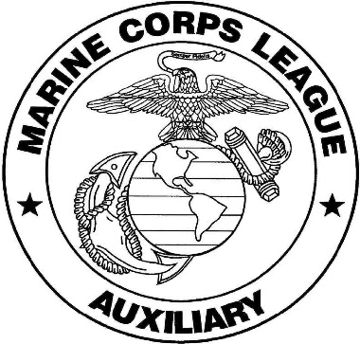

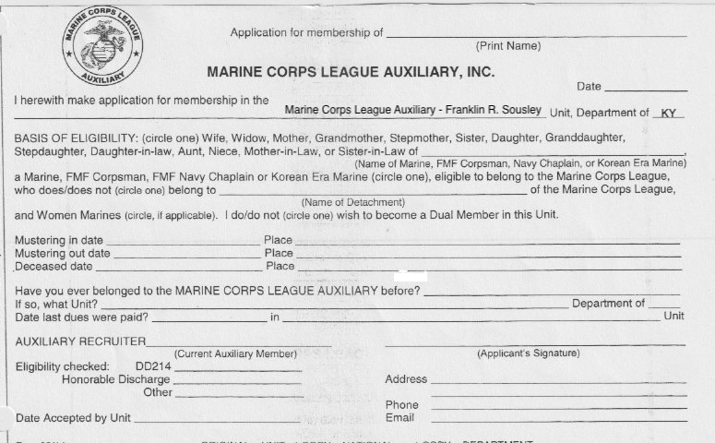

Mail completed form to:

Janel Doyle
7010 Morgantown Rd
Bowling Green, Kentucky 42101

